Vacuum Cleaner Problem
Aim:
To write a Python program to simulate a vacuum cleaner agent that cleans dirty rooms based on their states.
Algorithm:
- Start the program.
- Initialize the environment and the condition of each room.
- Position the vacuum cleaner in a room.
- Check whether the current room is dirty.
- If the room is dirty, clean it.
- If the room is clean, move to the next room according to the defined rules.
- Repeat until all rooms are clean.
- Display the final state of the environment.
- Stop the program.
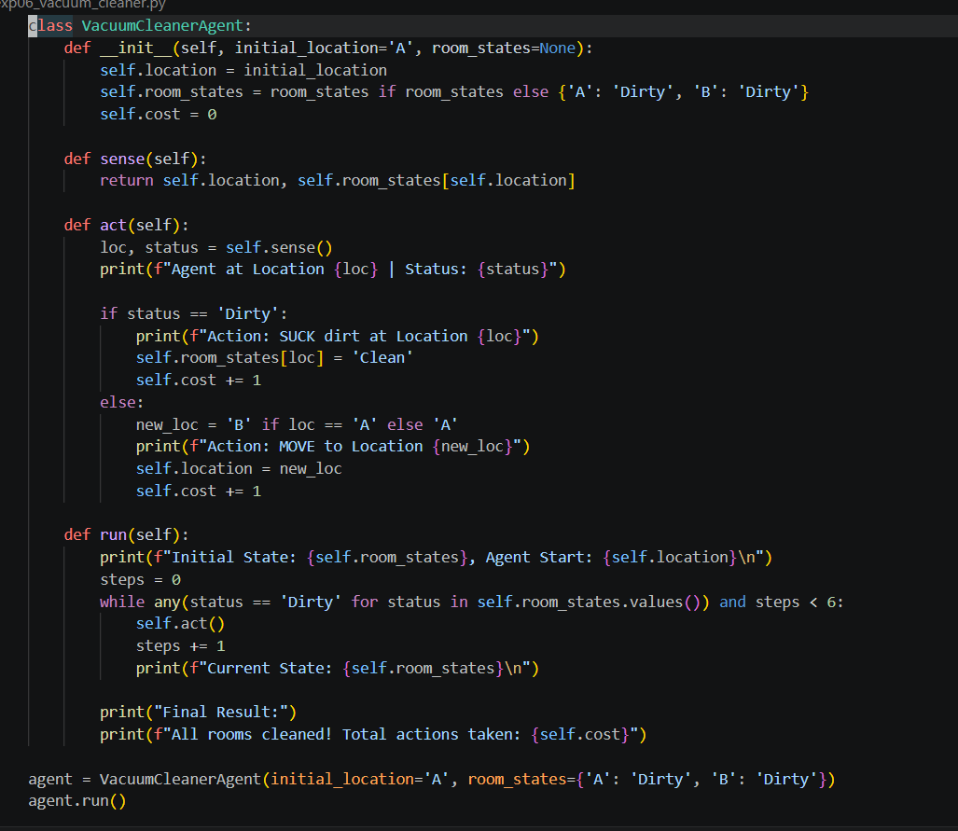
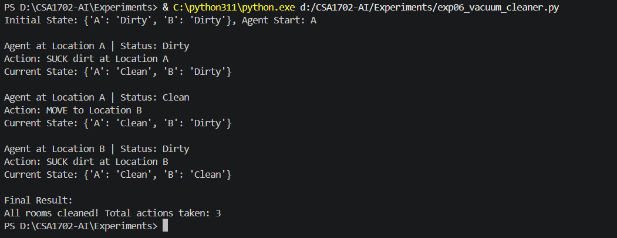
Code :
Output :
Result :
Thus, the Python program to simulate the Vacuum Cleaner Problem was executed successfully.

